The orginal image

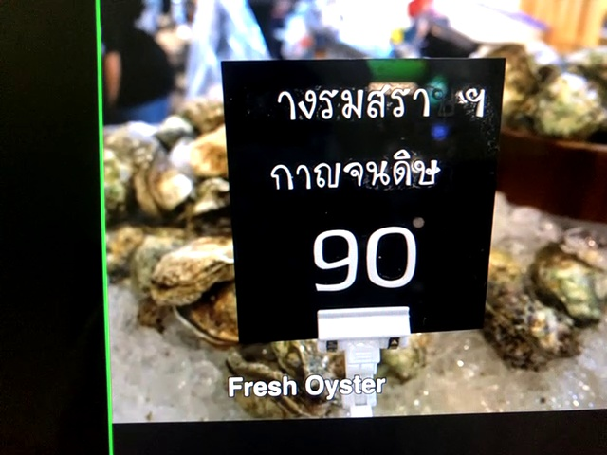

Grey scale

Binary image

Contour image

